LAB 2

-- 1. Create Tables

CREATE TABLE Airline_info (

    airline_id INT PRIMARY KEY,

    airline_code VARCHAR(30) NOT NULL,

    airline_name VARCHAR(50) NOT NULL,

    airline_country VARCHAR(50) NOT NULL,

    created_at TIMESTAMP NOT NULL,

    updated_at TIMESTAMP NOT NULL,

    info VARCHAR(50) NOT NULL

);

CREATE TABLE Airport (

    airport_id INT PRIMARY KEY,

    airport_name VARCHAR(50) NOT NULL,

    country VARCHAR(50) NOT NULL,

    state VARCHAR(50) NOT NULL,

    city VARCHAR(50) NOT NULL,

    created_at TIMESTAMP NOT NULL,

    updated_at TIMESTAMP NOT NULL

);

CREATE TABLE Passengers (

    passenger_id INT PRIMARY KEY,

    first_name VARCHAR(50) NOT NULL,

    last_name VARCHAR(50) NOT NULL,

    date_of_birth DATE NOT NULL,

    gender VARCHAR(50) NOT NULL,

    country_of_citizenship VARCHAR(50) NOT NULL,

    country_of_residence VARCHAR(50) NOT NULL,

    passport_number VARCHAR(20) NOT NULL,

    created_at TIMESTAMP NOT NULL,

    updated_at TIMESTAMP NOT NULL

);

CREATE TABLE Booking (

    booking_id INT PRIMARY KEY,

    flight_id INT NOT NULL,

    passenger_id INT NOT NULL,

    booking_platform VARCHAR(50) NOT NULL,

    created_at TIMESTAMP NOT NULL,

    updated_at TIMESTAMP NOT NULL,

    status VARCHAR(50) NOT NULL,

    price DECIMAL(7,2) NOT NULL

);

CREATE TABLE Flights (

    flight_id INT PRIMARY KEY,

    sch_departure_time TIMESTAMP NOT NULL,

    sch_arrival_time TIMESTAMP NOT NULL,

    departing_airport_id INT NOT NULL,

    arriving_airport_id INT NOT NULL,

    departing_gate VARCHAR(50) NOT NULL,

    arriving_gate VARCHAR(50) NOT NULL,

    airline_id INT NOT NULL,

    act_departure_time TIMESTAMP NOT NULL,

    act_arrival_time TIMESTAMP NOT NULL,

    created_at TIMESTAMP NOT NULL,

    updated_at TIMESTAMP NOT NULL

);

CREATE TABLE Baggage_check (

    baggage_check_id INT PRIMARY KEY,

    check_result VARCHAR(50) NOT NULL,

    created_at TIMESTAMP NOT NULL,

    updated_at TIMESTAMP NOT NULL,

    booking_id INT NOT NULL,

    passenger_id INT NOT NULL

);

CREATE TABLE Baggage (

    baggage_id INT PRIMARY KEY,

    weight_in_kg DECIMAL(4,2) NOT NULL,

    created_at TIMESTAMP NOT NULL,

    updated_at TIMESTAMP NOT NULL,

    booking_id INT NOT NULL

);

CREATE TABLE Boarding_pass (

    boarding_pass_id INT PRIMARY KEY,

    booking_id INT NOT NULL,

    seat VARCHAR(50) NOT NULL,

    boarding_time TIMESTAMP NOT NULL,

    created_at TIMESTAMP NOT NULL,

    updated_at TIMESTAMP NOT NULL

);

CREATE TABLE Booking_flight (

    booking_flight_id INT PRIMARY KEY,

    booking_id INT NOT NULL,

    flight_id INT NOT NULL,

    created_at TIMESTAMP NOT NULL,

    updated_at TIMESTAMP NOT NULL

);

CREATE TABLE Security_check (

    security_check_id INT PRIMARY KEY,

    check_result VARCHAR(20) NOT NULL,

    created_at TIMESTAMP NOT NULL,

    updated_at TIMESTAMP NOT NULL,

    passenger_id INT NOT NULL

);

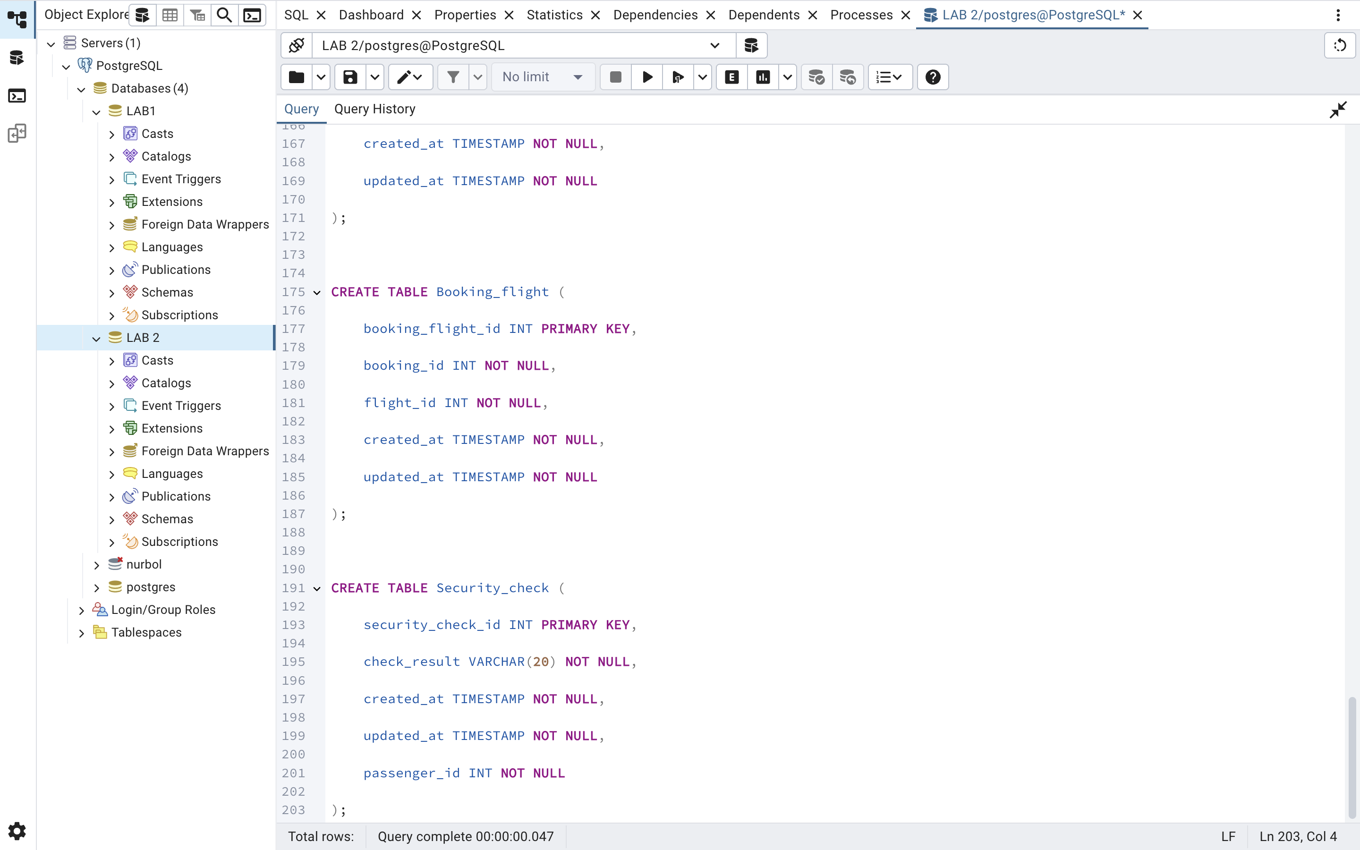

-- 5. Rename airline_info to airline

ALTER TABLE Airline_info RENAME TO Airline;

-- 6. Rename column price → ticket_price

ALTER TABLE Booking RENAME COLUMN price TO ticket_price;

-- 7. Change data type departing_gate to text

ALTER TABLE Flights ALTER COLUMN departing_gate TYPE TEXT;

-- 8. Drop column info

ALTER TABLE Airline DROP COLUMN info;

-- 9. Relationships

ALTER TABLE Security_check

    ADD CONSTRAINT fk_passenger_sec FOREIGN KEY (passenger_id) REFERENCES Passengers(passenger_id);

ALTER TABLE Booking

    ADD CONSTRAINT fk_passenger_booking FOREIGN KEY (passenger_id) REFERENCES Passengers(passenger_id);

ALTER TABLE Baggage_check

    ADD CONSTRAINT fk_passenger_baggage FOREIGN KEY (passenger_id) REFERENCES Passengers(passenger_id),

    ADD CONSTRAINT fk_booking_baggage FOREIGN KEY (booking_id) REFERENCES Booking(booking_id);

ALTER TABLE Baggage

    ADD CONSTRAINT fk_booking_bagg FOREIGN KEY (booking_id) REFERENCES Booking(booking_id);

ALTER TABLE Boarding_pass

    ADD CONSTRAINT fk_booking_boarding FOREIGN KEY (booking_id) REFERENCES Booking(booking_id);

ALTER TABLE Booking_flight

    ADD CONSTRAINT fk_booking_flight FOREIGN KEY (booking_id) REFERENCES Booking(booking_id),

    ADD CONSTRAINT fk_flight_booking FOREIGN KEY (flight_id) REFERENCES Flights(flight_id);

ALTER TABLE Flights

    ADD CONSTRAINT fk_dep_airport FOREIGN KEY (departing_airport_id) REFERENCES Airport(airport_id),

    ADD CONSTRAINT fk_arr_airport FOREIGN KEY (arriving_airport_id) REFERENCES Airport(airport_id),

    ADD CONSTRAINT fk_airline FOREIGN KEY (airline_id) REFERENCES Airline(airline_id);

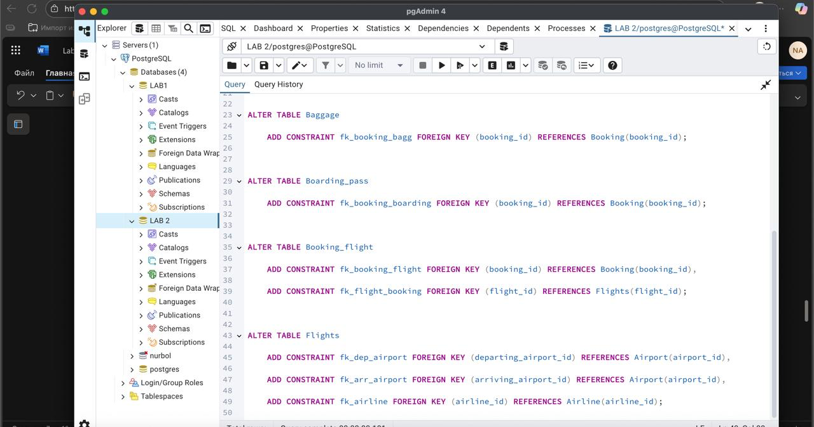

DML

-- 1. Insert 200 random rows into Airport (example for PostgreSQL)

INSERT INTO Airport (airport_id, airport_name, country, state, city, created_at, updated_at)

SELECT g, 'Airport_' || g, 'Country_' || (g%10), 'State_' || (g%5), 'City_' || (g%20),

       NOW(), NOW()

FROM generate_series(1,200) g;

-- 2. Add new airline

INSERT INTO Airline (airline_id, airline_code, airline_name, airline_country, created_at, updated_at)

VALUES (1, 'KZ001', 'KazAir', 'Kazakhstan', NOW(), NOW());

-- 3. Update country

UPDATE Airline SET airline_country = 'Turkey' WHERE airline_name = 'KazAir';

-- 4. Insert 3 airlines at once

INSERT INTO Airline (airline_id, airline_code, airline_name, airline_country, created_at, updated_at) VALUES

(2, 'FR001', 'AirEasy', 'France', NOW(), NOW()),

(3, 'BR001', 'FlyHigh', 'Brazil', NOW(), NOW()),

(4, 'PL001', 'FlyFly', 'Poland', NOW(), NOW());

-- 5. Delete flights arriving in 2024

DELETE FROM Flights WHERE EXTRACT(YEAR FROM sch_arrival_time) = 2024;

-- 6. Increase ticket price by 15%

UPDATE Booking SET ticket_price = ticket_price * 1.15;

-- 7. Delete tickets cheaper than 10000

DELETE FROM Booking WHERE ticket_price < 10000;

